
BioSciCon, Inc., Rockville, MD 20850
www.bioscicon.com
Option for m-Health Telecytopathology
BioSciCon’ Consortium of Companies, Rockville, MD, is developing a platform technology for wireless telecytopathology/telemicroscopy that uses mobile cellphone cameras for capturing microscopic images directly from the microscope in remote locations and wireless transmission of those images to distant centers for evaluation by professionals, with or without interceptions of web-based digital-image networking systems. The system provides opportunity for the results to be returned to the end users within hours. We have a patentable discovery that could be a revolutionary solution for improving health service delivery and surveillance in the developing world where it is most needed.
Some examples of images captured by digital CDC microscopic cameras and cellphone cameras (AT&T, Samsung, and Eternity) with our proprietary Universal Adapter are presented below. These are selected from the BioSciCon’ Galleries, where they are described in details. www.bioscicon.com/gallery.html. It is obvious that the images taken by digital cameras and cellphone cameras are comparable and that the image analysis or medical diagnosis could be performed interchangeably. Our proprietary Universal Adapter that can be used for “any microscope” and “any cellphone camera” is essential to obtain internal consistency reliability of the measures, allowing the diagnosis of abnormal condition.
BioSciCon continues working tirelessly to fulfill its mission bringing medical expertise closer to the point of care in the regions where it is most needed and could save more lives (www.bioscicon.com/pressrelease.html). To speed up this most recent development, BioSciCon welcomes investments and partners for co-development
FIGURES
All images captured with digital CCD camera (jpeg format) are in quadrangular frames. All images captured with the cellphone camera are in round frames. Different magnifications are presented. Please contact us for more information
Fig. 1-3 is different magnification of the same specimen/cells: Three small cells, with dark blue nucleus and red pigment in the cytoplasm, surrounded with big cells which are stained light blue. All images are similar, but the digital camera had the best illumination conditions Fig 4 -5 Although in single color (bluish) all morphological features are well preserved to allow cytological diagnosis. Our adapter-model needs more adjustment to provide for better illumination conditions. This adjustment will be done on the prototype Fig 6 – 7 are images captured from a control slide, made artificially from two types of cells for the purpose of quality control. These are small red cells and big blue cells. Again at different magnifications, but the illumination is better on the cellphone captured image than on the previous slides. Fig 8 – 9 presents images captured with CCD camera and cellphone camera from a cancer specimen. The MarkPap red biomarker (please see BioSciCon’ galleries) is present in abundance, both inside cytoplasm of individual cells and in the clusters of positive cells. This diagnosis cannot be missed by either technology
Fig. 1 Fig. 2 Fig. 3
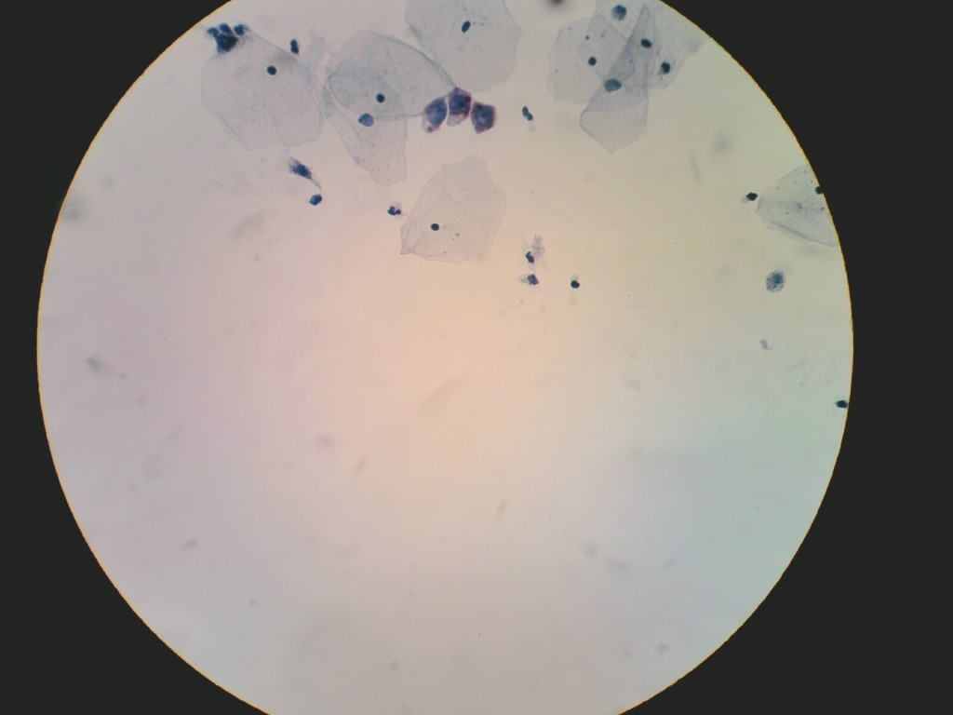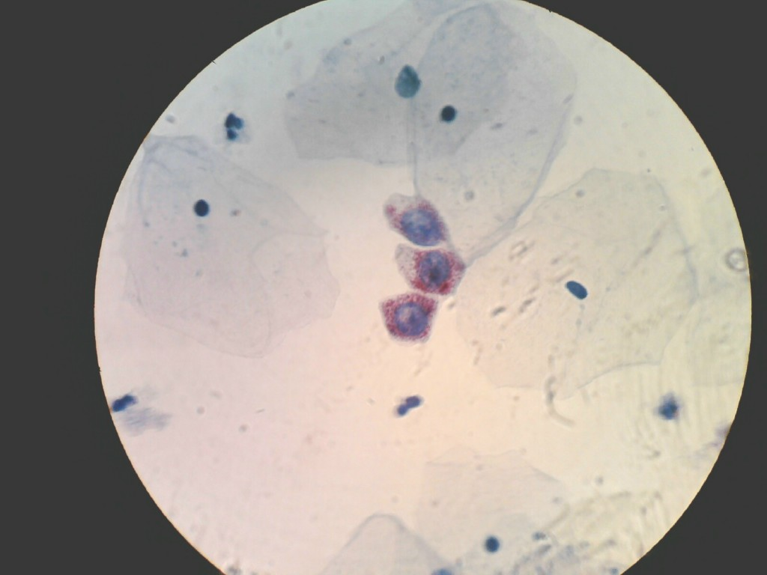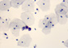
Fig. 4 Fig. 5
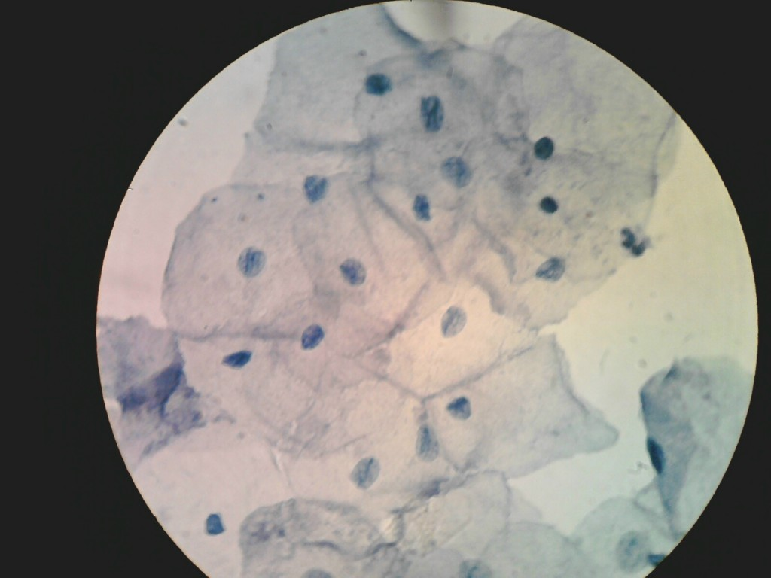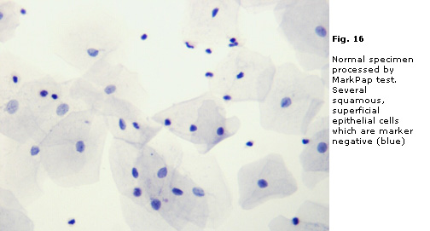
. Fig. 6 Fig. 7
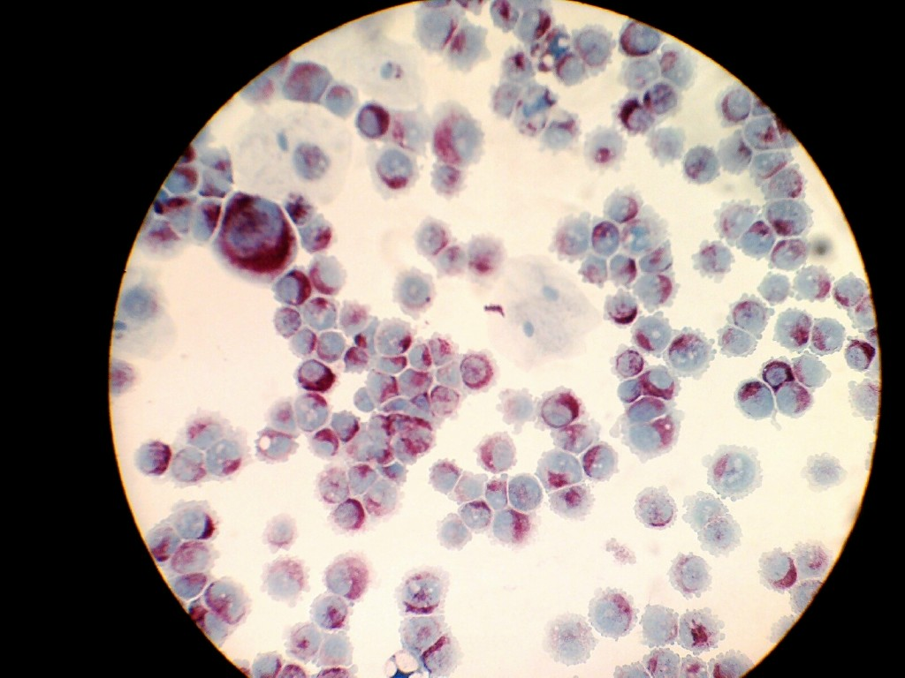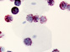
Fig. 8 Fig. 9
